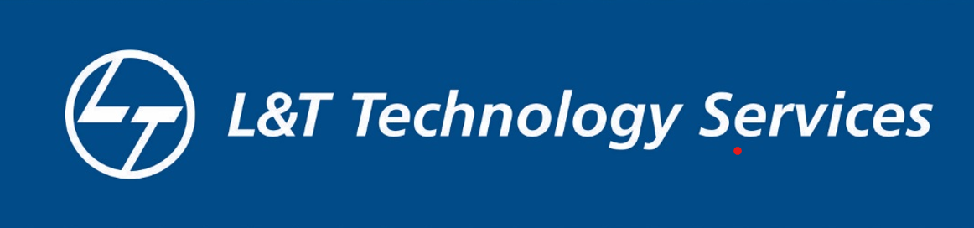

Report:

## Employee Management System

**Prepared by**

**Potlapati Ravi Chandra Reddy**

**08-02-2022**

**LTTS**

**Description of Project:**

Employee Management System is a distributed application, developed to maintain the details of employees working in any organization The EMS has been developed to override the problems prevailing in the practicing manual system.It maintains the information about the personal and official details of the employees.

# Research Objectives:

* This project aims to simplify the task of maintaining records of the employees of Company.
* To develop an well-designed database to store employee information.
* Provides full functional reports to management of Company.
* The objective of this project is to provide a comprehensive approach towards the management of employee information.

## features.

* Proper Login Screen (Invisible Password Typing).
* Password Protected.
* Encrypted File (Binary).
* Easily Add, Delete, Modify Records.
* Various Essential Queries.

**Conclusion:**

* This project aims to simplify the task of maintaining records of the employees of Company and data storing from a company.
* To develop an well-designed database to store this employee information.

.